

|  |
| --- |
| FusionInvest 7.1.3 |
| Management of Variation Margin for Listed Futures and Options |
| As prepared for Mediolanum |

|  |
| --- |
| Mac Aodha, Sean  9 September 2016 |



Contents

Document Control 3

Purpose 3

Revision History 3

Overview 4

Business Requirement 4

Implementation Approach 4

Process Flow Diagram 5

Variation Margin Support 6

Listed Futures 6

Listed Options 6

Margin Call Generation Types 6

Recommended Approach 7

Accounts Structure 8

Recommended Accounts Structure 8

Nostro Accounts for Clearing 8

Reflecting Variation Margin using Portfolio 10

Variation Margin Calculation 10

Using Dynamic PnL Columns 10

VM in Balance Column 10

Detailed Cash Balance 11

Reconciliation of Variation Margin using Reporting Module 12

Position and Trade Report 12

Variation Margin Report 12

Managing Payment of Variation Margin 13

Account Transfer Transactions in the Nostro 13

Cash Transfer Report using Reporting Module 14

Account Transfer Transactions in the Portfolio 14

Auditing Historical VMs 15

In the Portfolio 15

In the Variation Margin Report 16

What is New in 7.2.1 17

Principle 17

Variation Margin for Options 17

Collateral Clearing Module 18

Appendix 19

Appendix 1- Why you should not use the ‘Yes with ticket’ option 19

Appendix 2- Variation Margin Report Set-up for Intellimatch 20

Appendix 3- Cash Transfer Report Set-up for Integration Service 23

**© Misys Limited   
All rights reserved**

**Registered in   
England & Wales**

No. 01360027

**Registered Office:**One Kingdom Street Paddington   
London W2 6BL  
United Kingdom

Document Control

Purpose

This document aims to outline the best practice approach for management of Variation Margin related activities on the FusionInvest platform for listed futures and options.

Revision History

|  |  |  |
| --- | --- | --- |
| Date | Author | Comment |
| 09 Sep. 16 | S Mac Aodha | Initial version |
| 16 Dec. 16 | P Forcher | Revised version |
| 09 Jan 17 | J Shillingford | Cronos Comments |
| 25 Jan 17 | P Forcher | Final Version |

Overview

Business Requirement

It is understood that there is a requirement to compute and reconcile variation margin events on the FusionInvest platform for listed futures and certain classes of listed options: Options on equity Index, Options on single stocks, Options on fixed income futures, Options on currency futures, Options on Futures.

Executions need to be matched automatically with Goldman Sachs Clearing Broker reports and not to follow the current manual process.

Implementation Approach

Misys recommendation and strategy regarding Variation Margin in version 7.1.3 is as follow:

1. Definition of Clearing accounts as Nostro accounts: Accounts used by Clearing Members to process Variation Margin call.
2. Computation of Variation Margin per position in the Portfolio: Calculating the variation margin without generating any VM ticket.
3. External Reconciliation: Variation Margin report generated and exported from FusionInvest to be reconciled with the Clearing Member report within Intellimatch.
4. Generation of Margin Call instructions: Creation of Nostro cash transfer tickets from the Funds accounts to their Clearing accounts.

The purpose is to capture the margin call associated with futures and options and reflect it at the Nostro Management level, Cash Balance and Portfolio Reporting without generating tickets that can have significant impact on the portfolio performance. (You can find more details about our recommendation’s reasons in Appendix1).

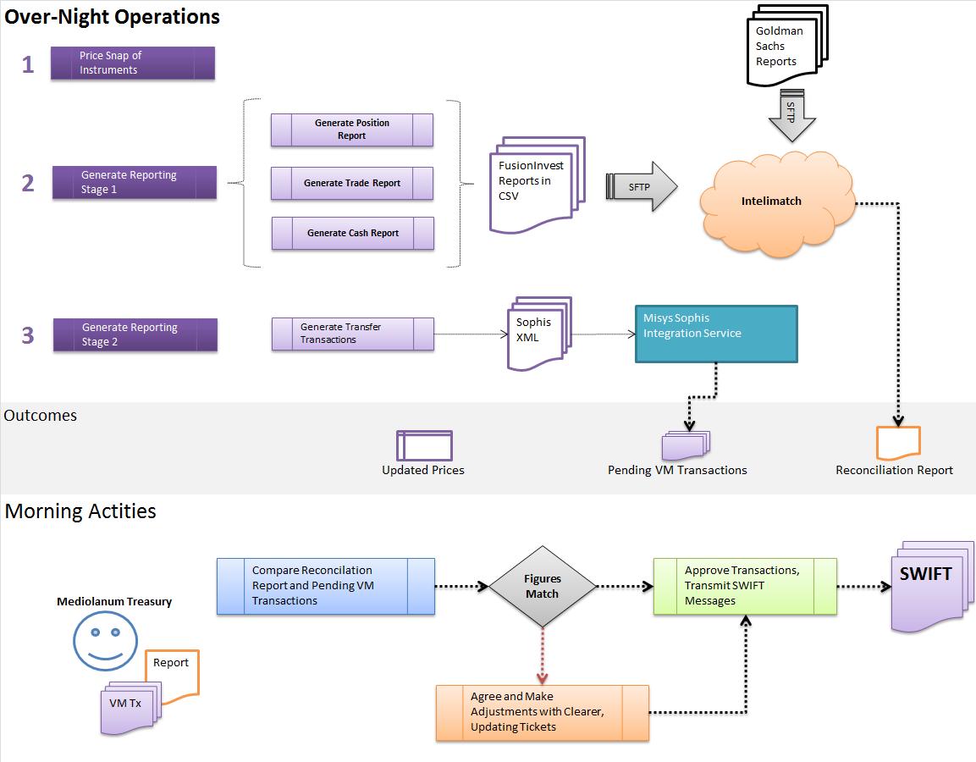Process Flow Diagram

At the end of the day, we will be generating:

* A Cash Report (Variation Margin Report) **to be reconciled** with Goldman Sachs Report within Intellimatch.
* An XML file for Integration Service **to create Nostro Cash Transfers** from the Funds accounts to their Clearing Accounts.

Cash Transfer Transactions will be created with Pending Status so the next day Mediolanum Treasury can:

* Check it
* Disagree and adjust it
* Approve and generate Swift message

PS: The Reconciliation is done automatically by Intellimatch. Medio are just reviewing the Report in the morning to check what is unmatched.

You can find in Appendix 2, a basic example of GMS file that will be reconciled through Intellimatch.

Variation Margin Support

Listed Futures

FusionInvest supports generation of margin call events for Listed Futures as standard.

It is always possible to restrict the generation using conditions (position allotment, underlying allotment, currency, etc.) in the “Variation Margin for Futures” window.

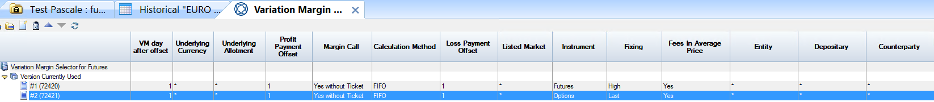

Listed Options

FusionInvest does not support generation of margin call events for listed options without a Toolkit.

It is proposed that a toolkit be deployed to enhance the behavior of eligible option instruments to behave like listed futures for the purposes of variation margin events.

The toolkit will involve setting a Boolean flag on eligible instruments. The Data Service (which provides Bloomberg data feeds to the platform) can be modified to automatically set the flag to true for the required instruments on creation.

The identified required instruments to generate variation margin events are as follows:

* Options on equity Index,
* Options on single stocks,
* Options on fixed income futures,
* Options on currency futures,
* Options on Futures

Margin Call Generation Types

The ‘Variation Margin for Futures’ Selector allows the configuration of “what to do” for margin call events:

* Yes, with Ticket
  + An automatic ticket, with business event Variation Margin, is generated for each position applicable.
  + This is a legacy configuration and is no longer supported for new implementations
* Yes, without Ticket
  + No automatic ticket is generated, but the impact of variation margin is reflected in the portfolio Balance column
  + This is the recommended configuration as it is supported by Misys.
* No
  + No impact on applicable positions at all.

Recommended Approach

In the next paragraphs we will be describing the Variation Margin implementation approach based on Misys recommendations and Best Practices which is without generating VM tickets. In the ‘Variation Margin for Futures’ Selector the column ‘Margin Call’ will be set to ‘Yes without Ticket’.

You can find more details about our recommendation’s reasons in the Appendix1. It is always possible to discuss any set-up point and adapt it to Mediolanum.s

Accounts Structure

Recommended Accounts Structure

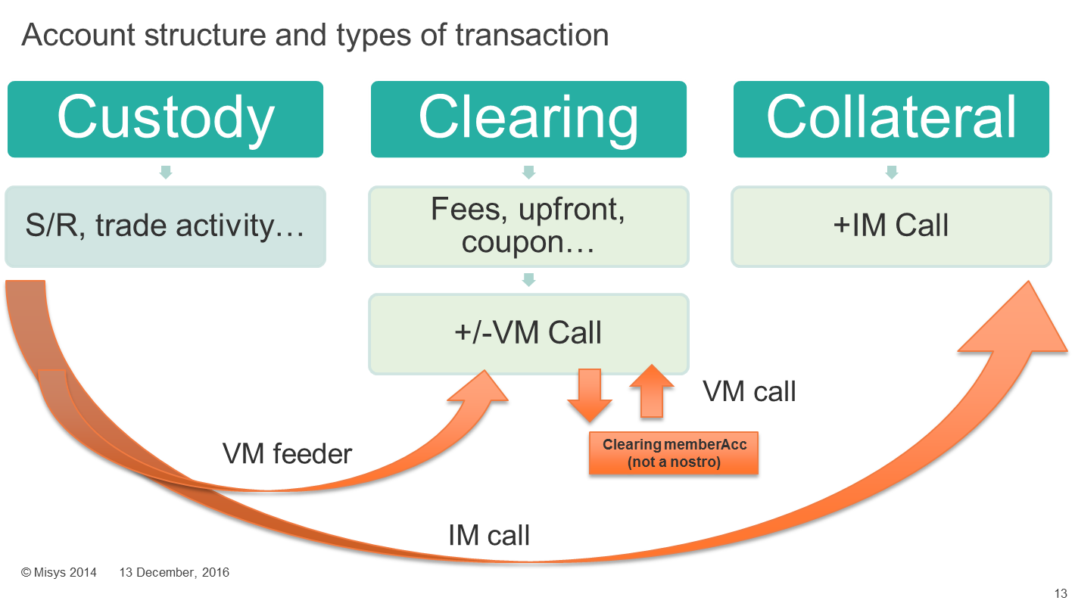

* Custody Accounts: Standard S/R and trade activity (e.g. RBC).
* Clearing Accounts: +/- Variation Margin Call (e.g. Goldman Sachs Clearing). JPM Clearing can also be set-up.
* Collateral Accounts: + Initial Margin Call if it is implemented.

Nostro Accounts for Clearing

As the clearing party holds an account for each reportable fund, it is proposed to correctly reflect this in FusionInvest using the Nostro Accounting Module.

It is proposed that a Clearing Account for each fund be setup, where the custodian is the Clearing party.

This account would have a portfolio within the Cash structure in the Fund and can be set as “blocked cash”.

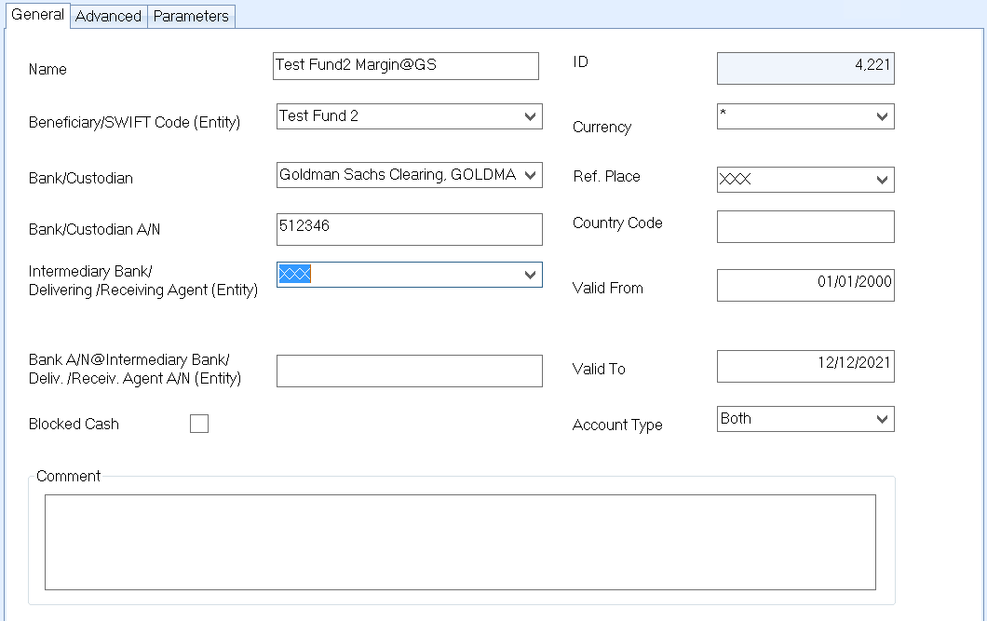

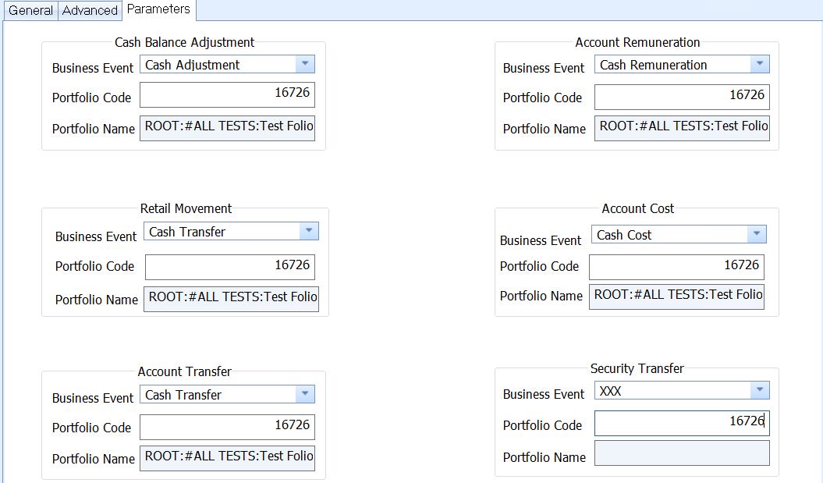

Reflecting Variation Margin using Portfolio

Variation Margin Calculation

The intraday calculation is made following this formula:

Variation Margin = (today's closing price - yesterday's closing price) x number of contracts x contract size.

By default, Variation Margin is calculated based on the LAST.

Using Dynamic PnL Columns

The Dynamic PnL functionality of the Portfolio Module allows the capture of PnL data at certain date points. This data can then be used as columns in the Portfolio workbook and in the Reporting module’s portfolio source to generate and export files.

As variation margin is calculated using the difference between the two last settled prices of an instrument, Dynamic PnL columns have been configured for Last (D-1), Last (D-2).

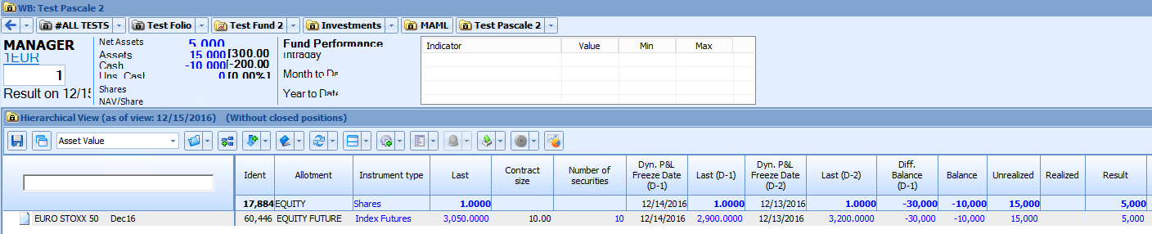

VM in Balance Column

With the proposed configuration of “Yes, without ticket”, the implied variation margin call is reflected in the Balance columns of the portfolio.

For example:

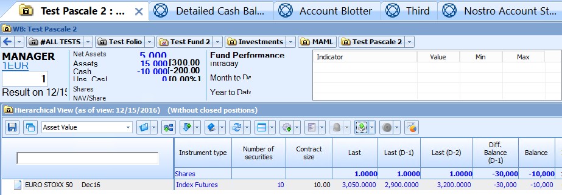

The Dynamic PnL column has calculated the **daily variation margin** to be -30 000€ on D in the column **‘Diff. Balance (D-1)’** using the formula:

Variation Margin = (Number of Securities x Contract Size) x (Last (D-1) – Last (D-2))

-30 000 = (10 x 10) x (2900 – 3200)

The column ‘Balance’ corresponds to the total amount of Variation Margin and not to the daily value.

Detailed Cash Balance

The Detailed Cash Balance reflect the **total** amount of Variation Margin per position.

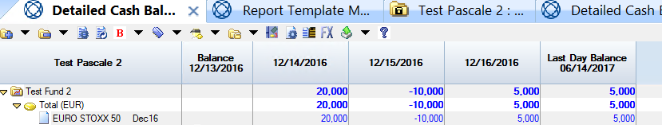

Reconciliation of Variation Margin using Reporting Module

Position and Trade Report

The over-night reporting activities require generation of Position and Trade reports to be sent via SFTP to the Intellimatch platform for reconciliation with the equivalent from the clearing party.

As the reports are run overnight, The position report contains the current state of the reportable positions (Futures, Listed Options with toolkit flag set to True) within reportable funds (those with accounts at Goldman Sachs) after EOD. Likewise, the trade report contains all Purchase/Sale transactions executed.

Variation Margin Report

The third report for reconciliation to be generated is the Variation Margin Report. This report contains the Variation Margin movements for the reportable funds.

As part of this proposal, it is required to configure this report in the Reporting Module to use only the Portfolio Source for variation margin data points. It has been established that the Dynamic PnL columns such as Last D-1, Last D-2 and ‘Diff. Balance D-1’ can populate the required fields for reconciliation.

An XSL template should be developed to transform the XML file into a CSV file to be sent to Intellimatch for reconciliation.

You can find more details about the set-up in the Appendix 2.

Managing Payment of Variation Margin

Account Transfer Transactions in the Nostro

When a variation margin requires the movement of Cash to/from the fund’s available cash account (ex. Challenge European Equity MAML) to the Clearing party, Cash transactions can be used within the Nostro module to instruct payment between the accounts.

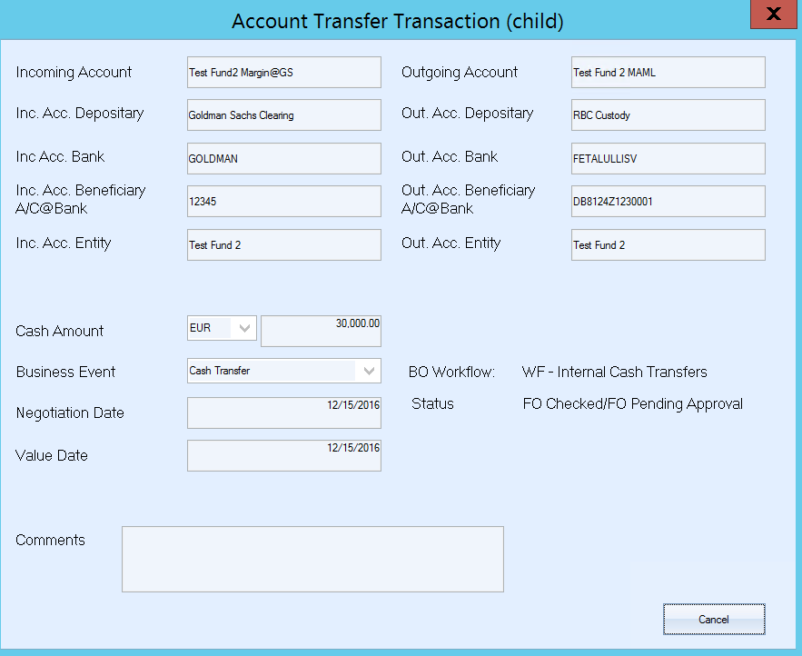

Account Transfer transactions can be initiated at any time using the Nostro Module. They can be configured to automatically send a SWIFT message upon relevant approval using the appropriately configured Back Office Trade Workflow.

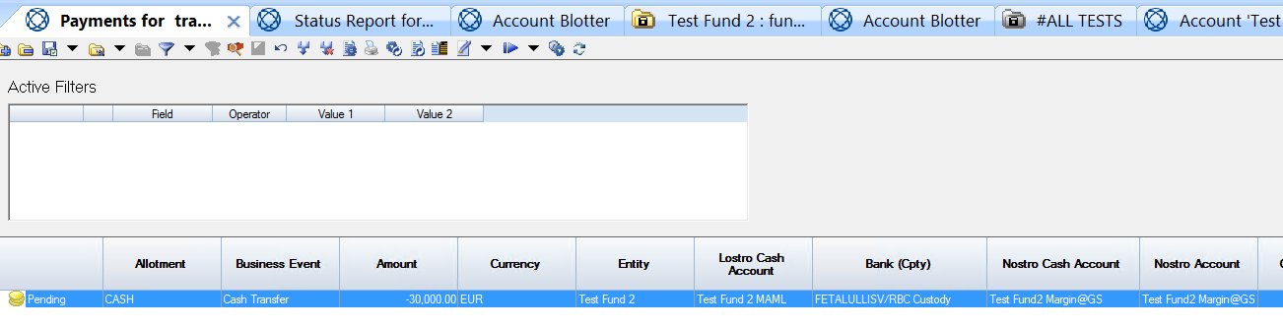

Cash Transfer Report using Reporting Module

It is proposed that during the over-night activities a fourth report is generated, to populate XML files for consumption by the Misys Sophis Integration Service to create Account Transfer Transactions or Simple Cash transactions. An exception file is always generated with the errors.

These transactions will be available for review by Users during the morning activities. Each transaction will be for the reckoned variation margin per Fund, per Currency. Like any transaction within Misys, they can have a specific blotter and workflow.

Should the reckoned margin not match with statements from the Clearing party, a decision can be made to adjust the payment to cover (in case of rounding breaks) or instruct to adjust an offending position (in case of position break)

Otherwise, should no inspection of the payments be required, the platform can be configured to automatically send instruction for payment/receipt of cash.

The fourth report is to be configured as well in the Reporting Module to use only the Portfolio Source for variation margin data points. It is recommended to be grouped by currency so it generates cash transfer for the total daily Variation Margin by Currency.

An XSL template should be also developed to transform the XML file into an XML file as required by the Integration Service.

You can find more details about the set-up in the Appendix 3.

Account Transfer Transactions in the Portfolio

As Nostro cash transfer transactions generate a position in the portfolio, it is possible to see this action within the portfolio workbook without impact on the Result.

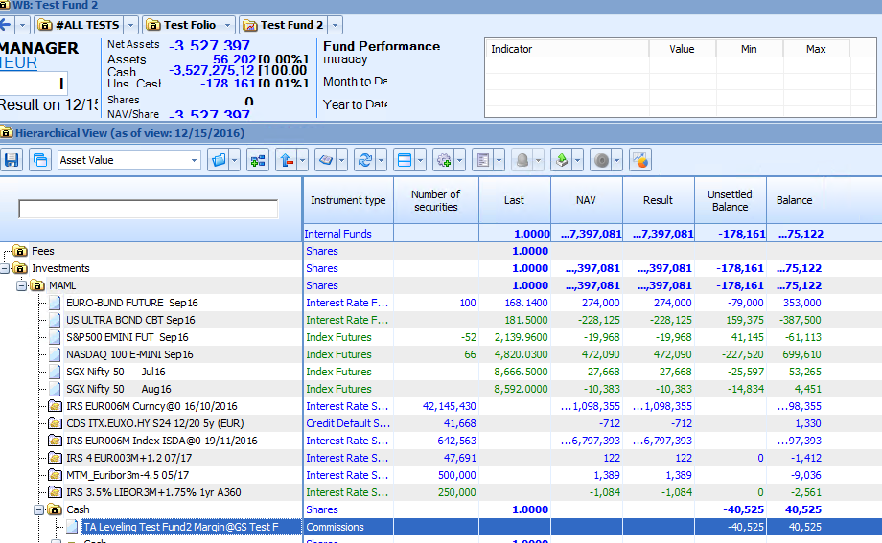

Auditing Historical VMs

In the Portfolio

If you need for any Audit reason, review old VM values and transactions. You can anytime:

* Do a Prices Date and select the date you want to Audit.
* Flag “Positions” and “Audit Trail” to ensure you have a correct snapshot of that day.
* Analyze your Portfolio with the Dynamic PnL columns

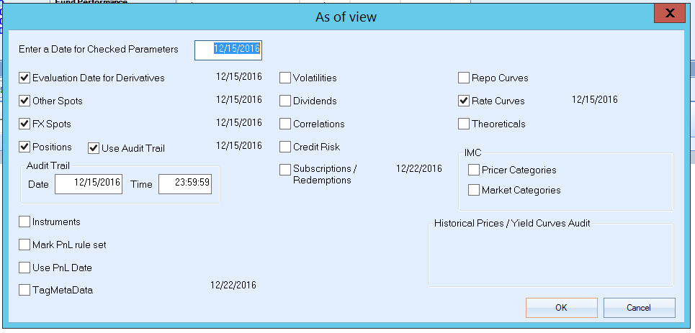

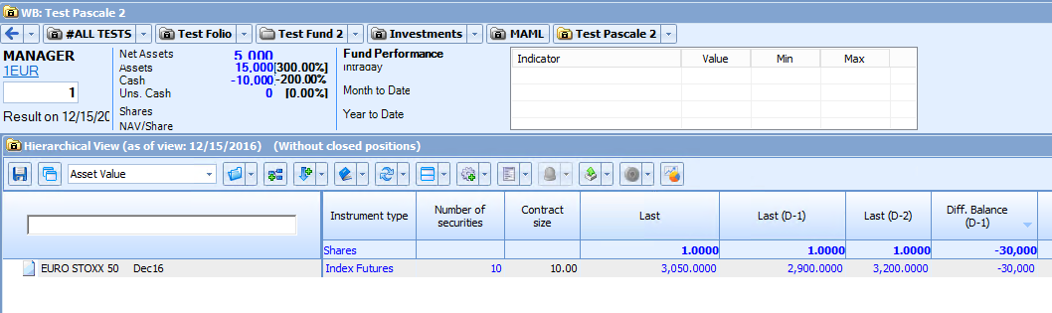

In the Variation Margin Report

On the top of analyzing the FO values, you can always run the Variation Margin Report in the Reporting Module with a date in the past.

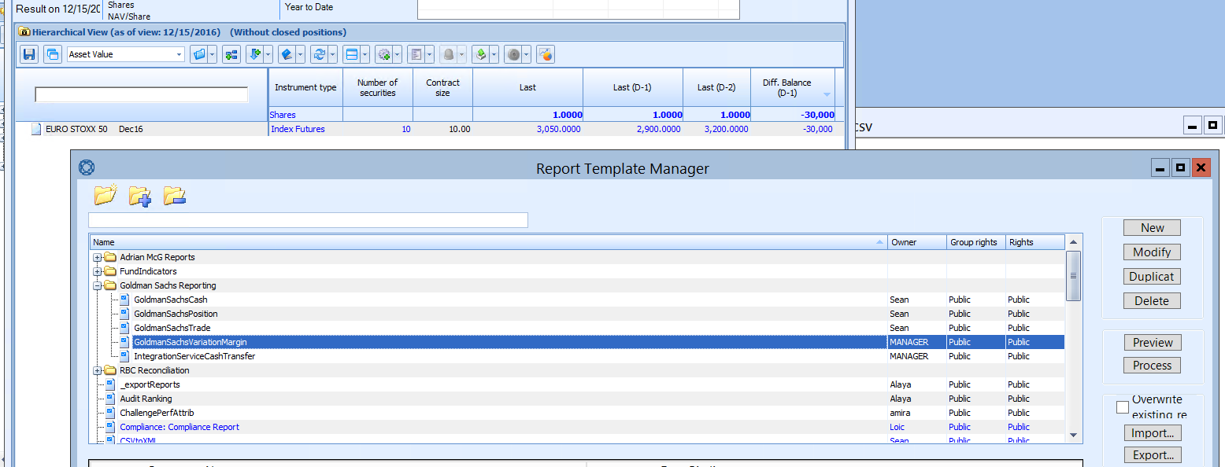

Generate the csv file and save it in Excel.

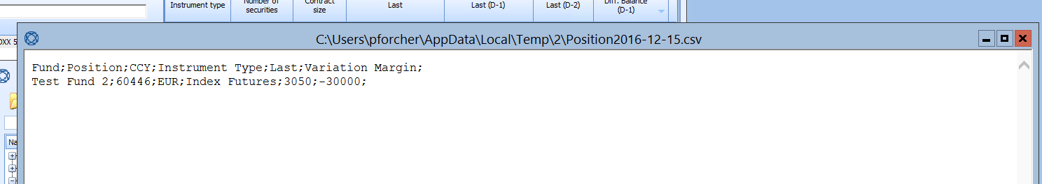

**PS:** In general the csv file generated in the VM Report can be saved on a specific folder by date. So you can save them under your Data Warehouse and use them any time for an Audit.

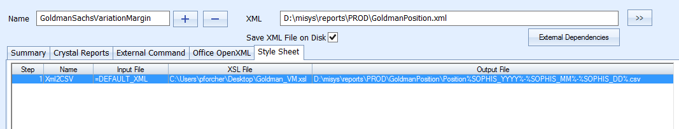

What is New in 7.2.1

Principle

In FusionInvest 7.2.1, new functionalities have been developed related to the Variation Margin and Collateral Management. You can find below a summary.

Enhancements were made at several levels but it doesn’t mean the work that has been done so far in 7.1.3 will need to change. We will need to set-up only the new functionalities that Mediolanum considers needed to implement.

The set-up and the behavior can always remain the same in the new version.

Variation Margin for Options

One interesting enhancement for Mediolanum will be the Variation Margin Management on Options, which will have in standard without toolkit, the same behavior than the Futures.

The behavior and set-up to be kept:

* Trade booking

Trade is booked in portfolio and the Net amount is computed only using fees.

* Portfolio

In the same trade date, the Balance consists only in fees. In the following days, the calculated asset value is added (The PnL is paid every day, as opposed to remain theoretical until the contract is terminated).

Asset value is calculated using the trade price and the average price in the booking date, in the following dates the booked price is not used anymore but the last from the current day.

* Nostro

Virtual Margin calls are calculated based on the asset value for each day.

* Detailed Cash Balance

The calculated virtual margin calls are seen as cash flows and the balance is computed using this cash flows.

* Forecast

Creates ticket at maturity.

The idea will be to flag a new field ‘is cleared’ at the instrument level which will change the option behavior so that variation margin calculation is identical to the Futures.

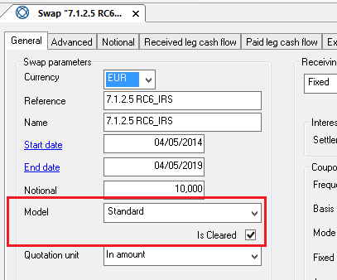

Impact will be:

* In portfolio: PnL is moved to balance everyday
* In deal input window: net amount = 0 ( like for future, upfront fee is paid in the next day margin call)

Collateral Clearing Module

This new Clearing topic within the Collateral Module has a lot of objectives especially for clients using the Collateral Module. But what can be interesting for Mediolanum is the import part of a clearing statement from the Clearing Member, using Integration Service (high volume – daily process) that will reflect margin call as they happen in reality (not just a theoretical value displayed).

Appendix

Appendix 1- Why you should not use the ‘Yes with ticket’ option



Appendix 2- Variation Margin Report Set-up for Intellimatch

The Variation Margin Report to be sent to Intellimatch will contain the Variation Margin movements for the reportable funds.

For that we need first to define the extraction concerned by this report (GS Reportable), where we can filter the concerned Funds and Allotments.

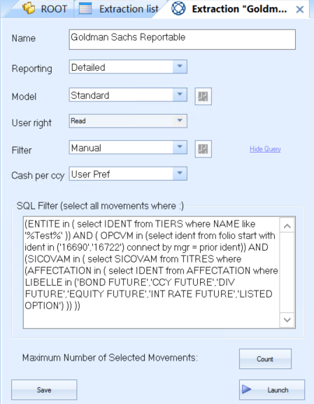

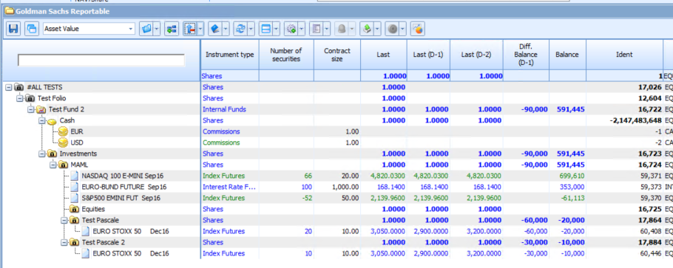

Then, it is required to configure this report (GS Variation Margin) in the Reporting Module with the Portfolio Source.

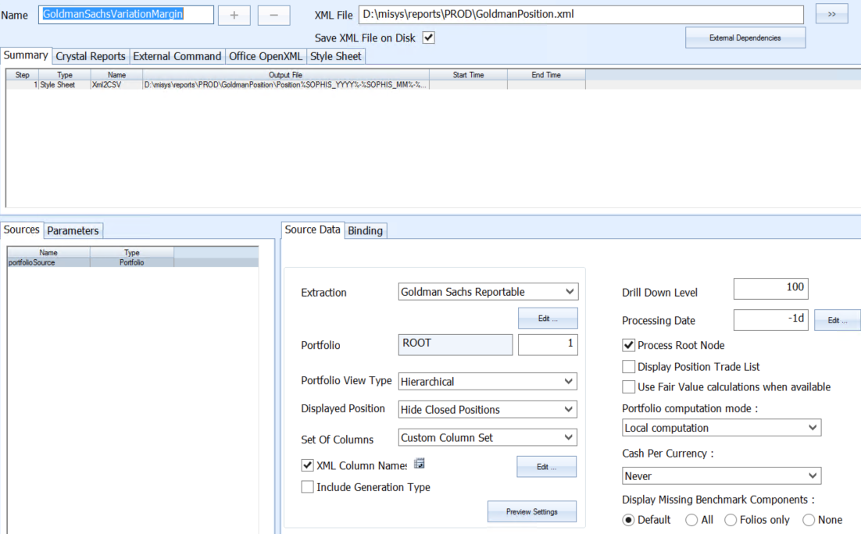

In the ‘XML column Name’ we select the required columns from the Portfolio:

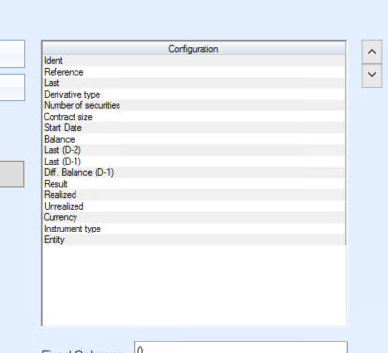

The Report ‘GS Variation Margin‘ will generate an XML file following the extraction and the selected columns:

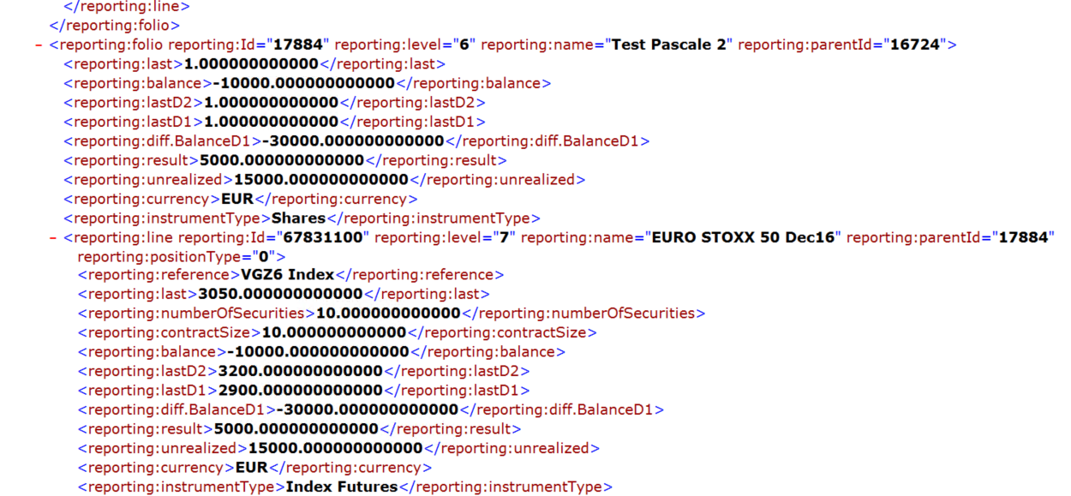

An XSL template (Goldman_VM.xsl) should be developed and loaded in the report Style Sheet. It will transform the XML file into a CSV file as required by Intellimatch.



The csv file will be saved under ‘Output File’ to be sent to the platform for reconciliation:



***PS:*** *Please note that this is just an example, we need to review it and adapt it.*

Appendix 3- Cash Transfer Report Set-up for Integration Service

The Variation Margin Report to be sent to the Integration Service will contain the Variation Margin movements for the reportable funds grouped by Currency.

For that we need first to define the extraction (GS Reportable by Currency) concerned by this report, where we can filter the concerned Funds and Allotments and do a grouping by currency.

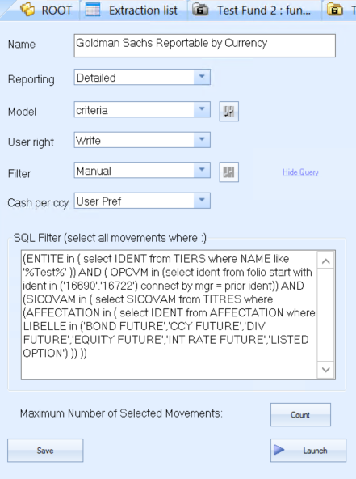

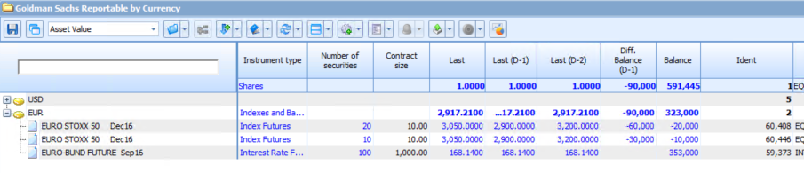

Then, it is required to configure a report (Integration Service Cash Transfer) in the Reporting Module with the Portfolio Source using the previous extraction.

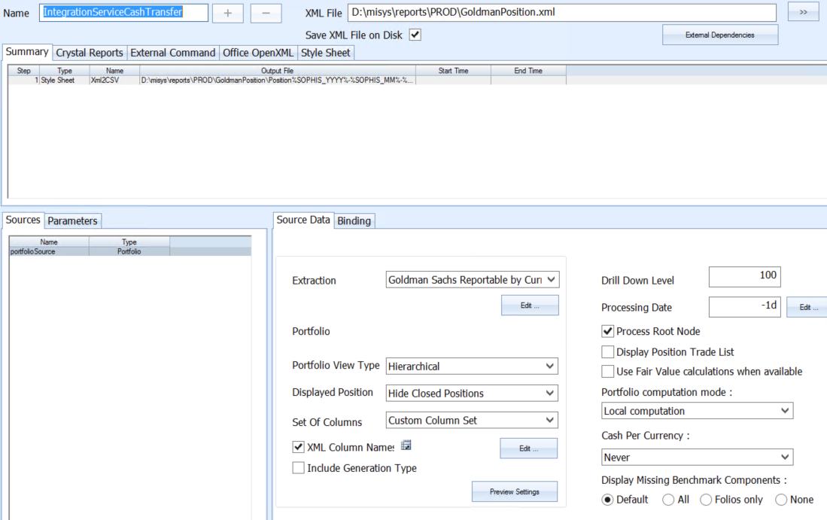

In the ‘XML column Name’ we select the required columns:

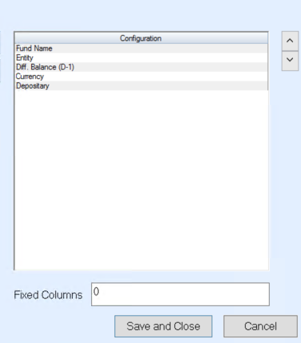

The Report will generate an XML file:

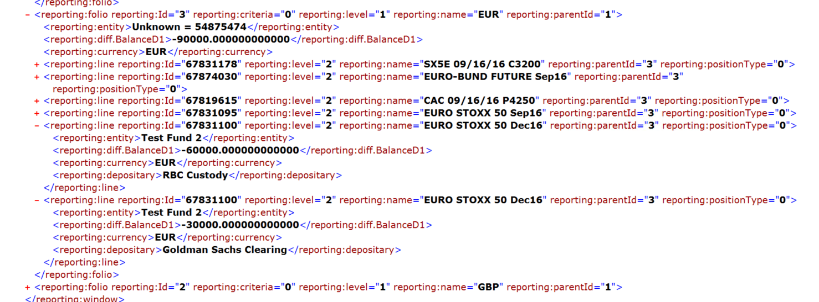

An XSL template should be developed to transform the XML file into an XML file as required by the Integration Service.

The new XML file will be saved in ‘Output File’ under ‘In’ Folder of the Integration Service. Below an example.



